DHM Volume Visualizer User Guide
Purpose: The DHM Volume Visualizer is an RShiny application designed to help users understand and monitor patient volumes across service lines and teams. This guide explains how to operate the app and make the most of its features.
Goal: The goal of this app was to support DHM in providing care for over 50% of the patients at CU Hospital by developing a data visualization dashboard that tracks and monitors patient volumes and capacities for each service line and team. By reviewing plots and metrics of recent time periods, users can:
- Identify short-term trends in patient volumes and spot upward or downward shifts in demand
- Monitor current operational health, including volumes and capacities for each team
- Flag teams/service lines at risk of exceeding 90% or 100% capacity
- Anticipate upcoming surges in patient volume and adjust staffing before escalation
While forecasting is not yet implemented, the app enables proactive planning by highlighting emerging trends, and lays the groundwork for the application of future predictive models.
Who: This RShiny Data Visualization app was made by Sean Vieau as part of this Fall 2025 Practicum with DHM, under the supervision of Dr. Angela Keniston.

Plots
Below are descriptions and images of the selected idioms used in this app.
- Volume Line Plots:
  - The primary visualization is a line plot depicting the average patient volumes over the selected look back period.
  - A grey dotted line overlays the maximum capacity, enabling viewers to visually compare patient flow against available resources.
  - This plot emphasizes temporal trends and highlights periods where volumes approach or exceed capacity thresholds.
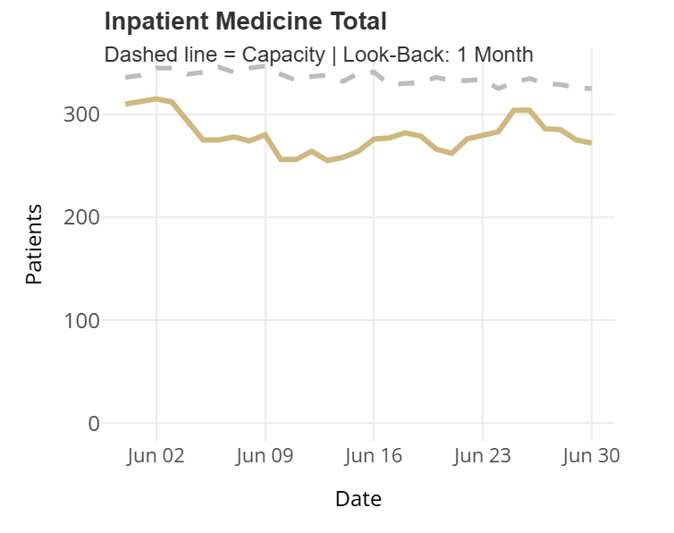
- Capacity Bar Plots:
  - As a companion view, average patient volumes are expressed as a percentage of maximum capacity.
  - This transformation allows users to capture changes in a moving capacity environment, where thresholds may shift over time.
  - Dotted grey reference lines at 90% and 100% capacity provide immediate visual cues for critical ranges, helping stakeholders identify days when operations were at risk of overload.
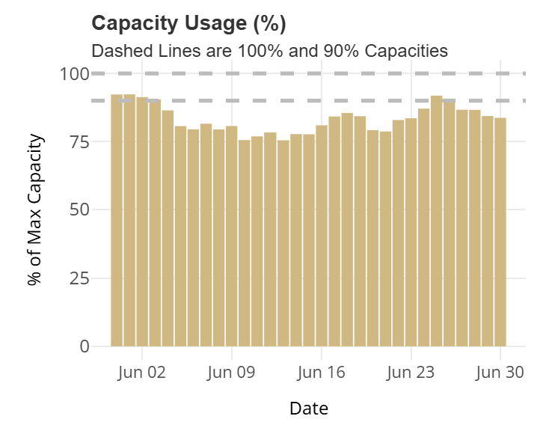
- Change Plots:
  - The change plot illustrates the day-to-day increments or decrements in patient volume.
  - By focusing on differences rather than absolute counts, users can pinpoint inflection points, sudden surges, or drops that may explain broader trends or outlier days observed in the line and bar plots.
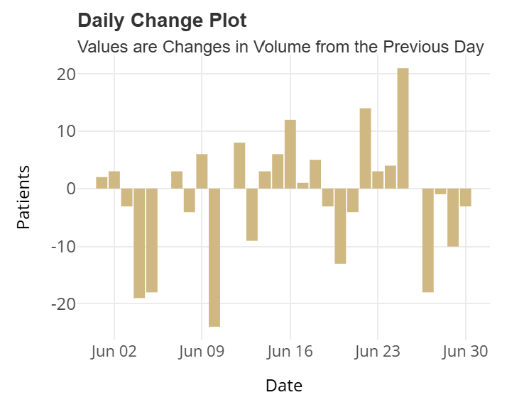

- SPC X Bar Chart:
  - As requested by stakeholders, the app implements a Statistical Process Control (SPC) X-bar chart, denoting the average patient volume across time.
  - Control limits are applied to identify time points outside of statistical control, offering insight into unusual variation beyond expected norms.
  - Importantly, the R package used does not implement the full suite of Shewhart rules; it flags only those days outside the normal range of standard deviation.
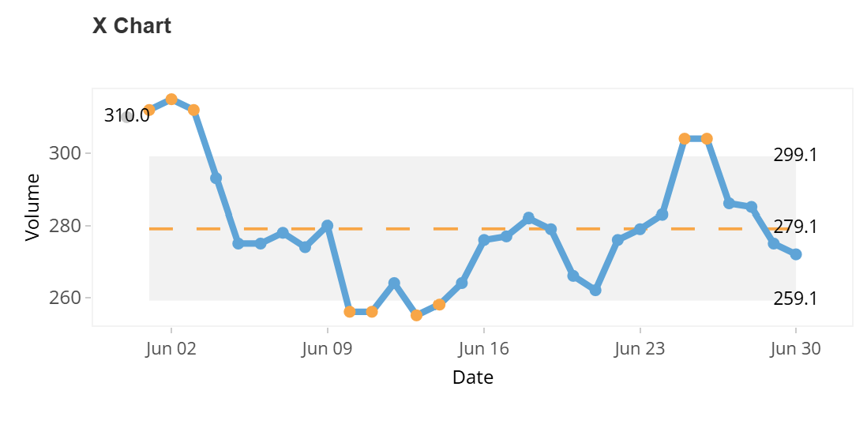
- SPC Moving Range (mR) Chart:
  - Alongside the X-bar chart, the moving range (mR) chart is included to denote the variability between successive observations.
  - This chart highlights short term fluctuations in patient volumes, complementing the X bar chart by showing whether changes are stable or erratic.
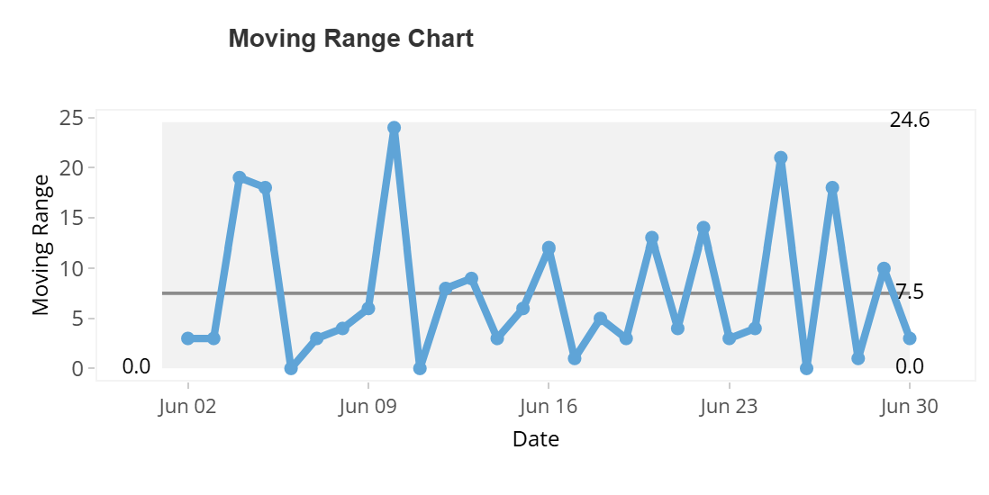

Metrics
The following metrics were selected by the team to provide meaningful insight into how service lines and teams are performing, as well as to highlight potential risks of overburden that may require intervention or additional staffing. All values are averaged over the user selected look back period (e.g., if one month is selected, metrics represent the average daily values across that month). These measures are subject to change and may be updated, removed, or expanded at the discretion of Clinical Operations.
Top Line Metrics
These measures provide organization‑wide visibility into the operational health of DHM. They serve as a bird’s‑eye view of overall performance, highlighting whether patient demand is increasing or decreasing, how close the system is operating to capacity, and where risks of overburden may emerge
- Average % Capacity Used (vs. Previous Look Back Period): A high-level summary metric showing the change in average capacity usage compared to the prior period. Enables users to quickly see whether overall utilization increased or decreased (e.g., this month vs. last month, or this week vs. the prior week).
- Number of Service Lines with Average % Capacity > 90%: Counts how many service lines operated above 90% of capacity on average during the selected period. Serves as a clear flag for areas at risk of overburden.
- Number of Teams with Average % Capacity > 90%: Same calculation as above, but at the team level. Identifies specific teams operating near or above critical thresholds.
Group-Level Metrics
These measures provide insight into how individual groups are performing over the selected look-back period, highlighting both average workload and periods of strain that may require intervention.
- Average Daily Volume: The mean number of patients seen per day across the look-back period. Establishes a baseline workload for each group.
- Average Capacity: The mean available capacity over the same period. Captures fluctuations in staffing or resource availability that affect how much volume a group can handle.
- Average % Capacity: Calculated as (Average Daily Volume ÷ Average Capacity) × 100. Provides a normalized measure of utilization, making it easier to compare across groups of different sizes.
- Days > 90% Capacity: Counts the number of days a group operated above 90% of its capacity. Serves as a risk indicator for potential overburden.
- Consecutive Days > 90% Capacity: Tracks streaks of consecutive high-utilization days. Highlights sustained strain, which can be more concerning than isolated spikes.
- Days at 100% Capacity: Flags days when a group was fully saturated. A clear signal that intervention or additional staffing may be required.

Design Philosophy
This app was developed with Munzner’s Rules of Thumb for effective visualization in mind, particularly “overview first, zoom and filter, then details on demand.” The design follows a funnel approach that progressively narrows the scope of information, allowing users to move from broad organizational insights down to granular team-level detail.
- High-level summary metrics provide a quick snapshot of overall operational health across DHM.
- These summaries then narrow into Inpatient Medicine total plots and metrics, providing aggregate level information.
- Futher down, interactive cards for individual Service Lines allow users to expand and view all corresponding plots and metrics for that line.
- For deeper exploration, the “Inspect Teams” button enables drill-down into the metrics and plots of all teams comprising that Service Line.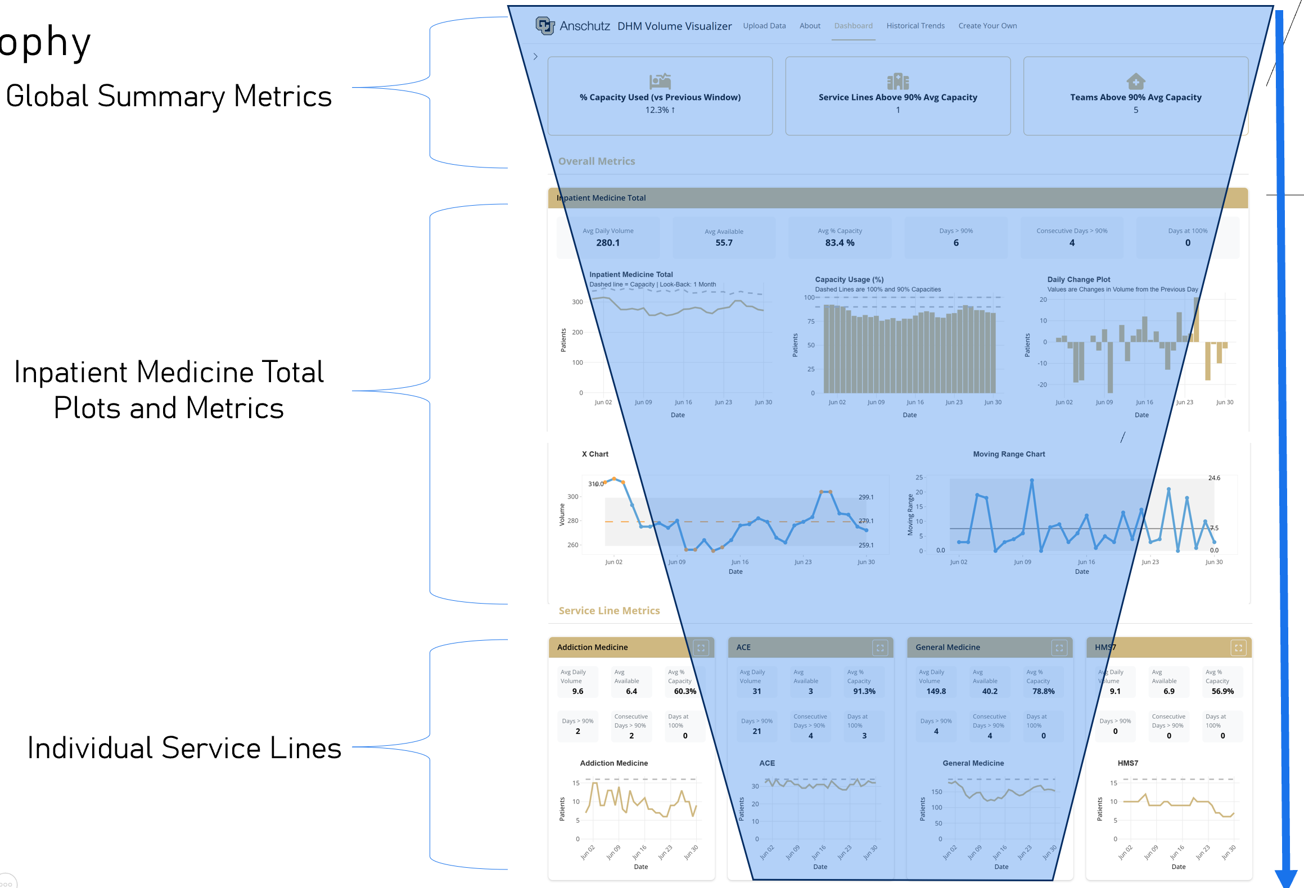

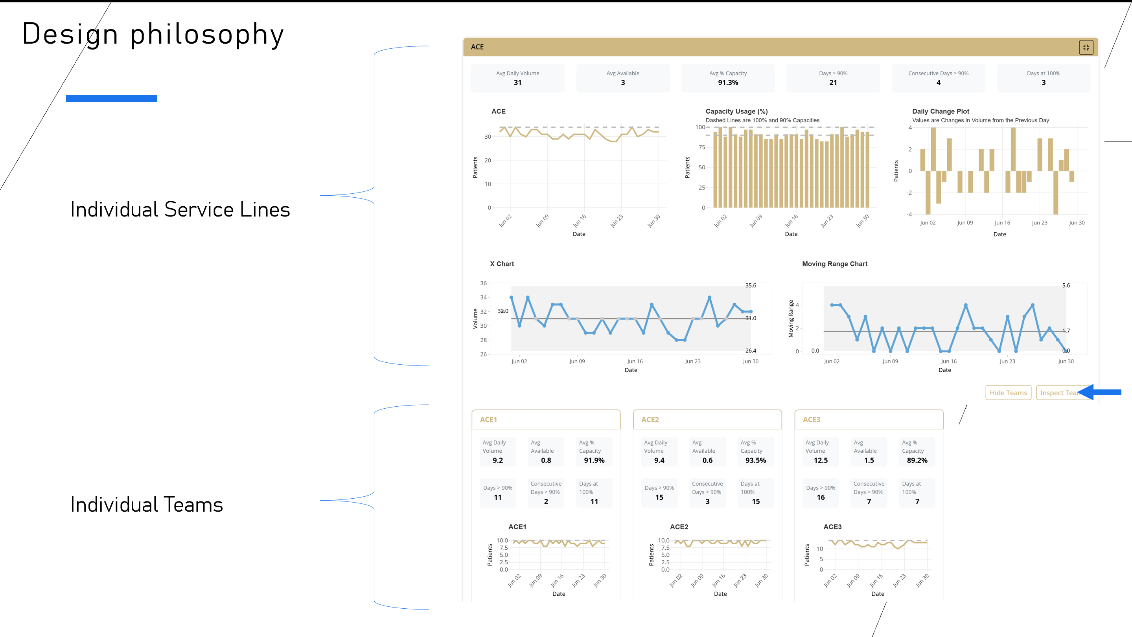

How-To Use App
- Load the app.
  - This will take different forms depending on how we choose to deploy the app. Currently it is only useable directly in R. Ideally this will be deployed as a secure app on the Posit server, and the user will access it via a password-protected link, ensuring protection of Hospital data.
- This will take you to the landing page where you are prompted to upload the data sets. This app will only work if the correct data sets are uploaded. Currently it requires:
  - The latest census data sheet
  - The latest capacities data sheet
    - In the future, we will incorporate target capacities as determined in the grants.
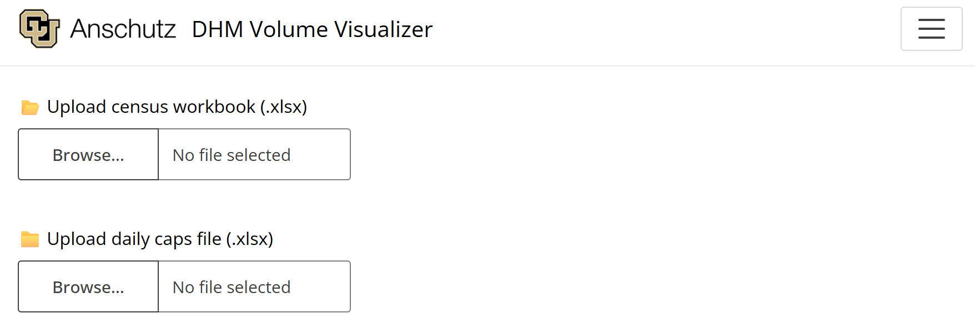
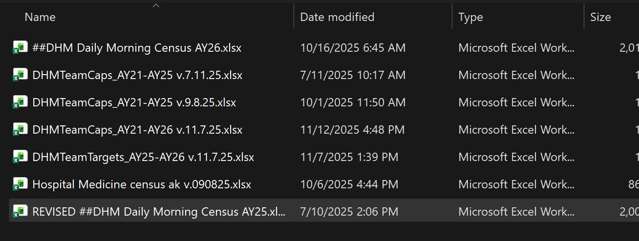
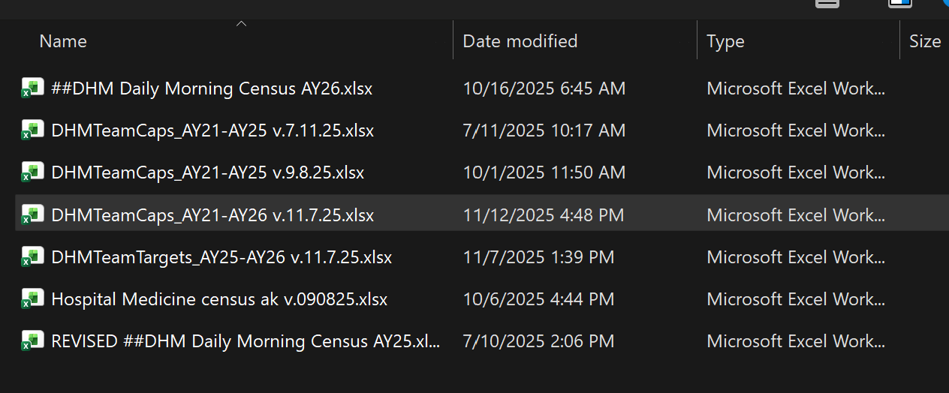

- Once both files have completed uploading, click “Process Data”
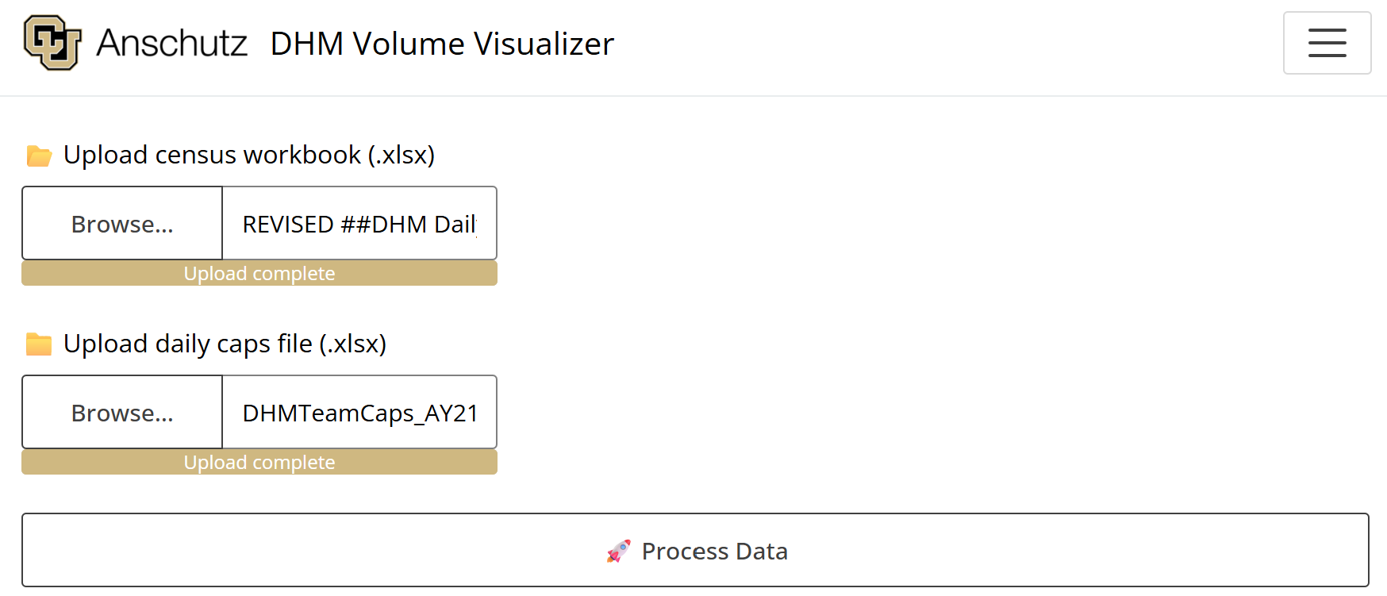
  - You will see an icon showing the app is processing. Wait until completion and a message saying data is finished processing



Dashboard
- Navigate to the “Dashboard” panel. Allow time for plots to render
  - Here you are greeted with all metrics and plots over the previous month (default look back period)
- To change the Look-Back Period, simply select the desired window using the filter on the siderbar.
  - Clicking reset will reset to the default (1 month)
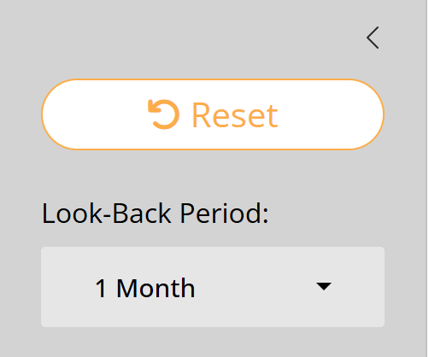
- To expand a Service Line card, simply click the box at the top right of the card
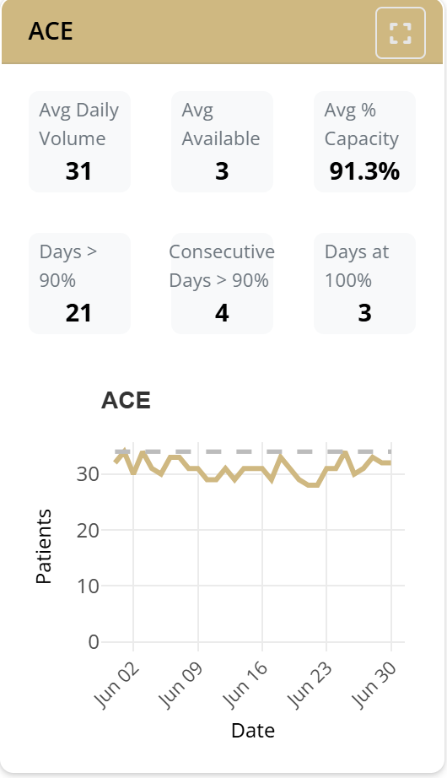
- To view metrics and plots for teams, click “Inspect Teams” at the bottom right of the corresponding expanded Service Line card.
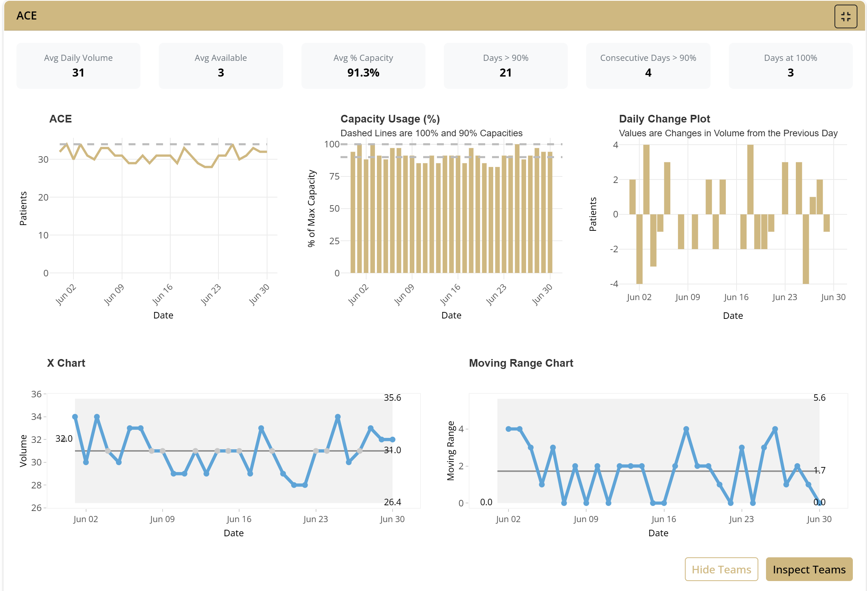
- Note that all plots have mouse-over interactivity for tooltips to examine exact values for a given date.
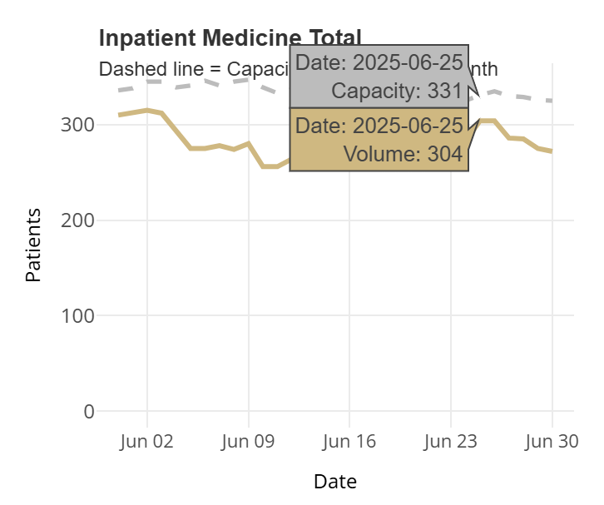
Create Your Own Plot
- Navigate to the “Create Your Own” panel at the top.
- Here you are greeted with the main plot, where all selected groups will populate.
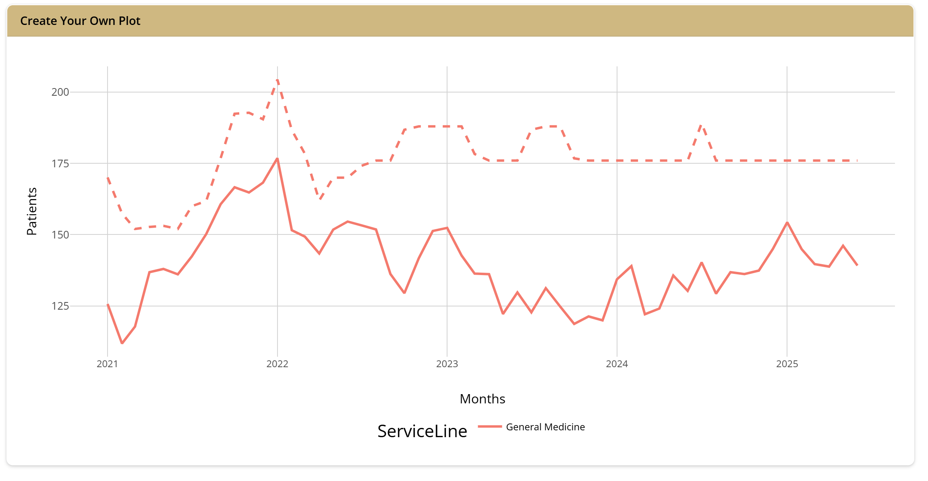
- On the side bar you will see several options, allowing you to
  - Select a desired date range
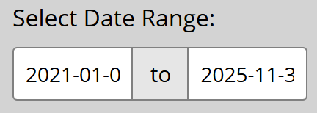
  - Smooth or increase granularity by aggregating by different bins
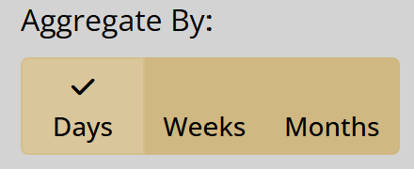
  - Add Service Lines to the main plot by selecting them in the drop down box
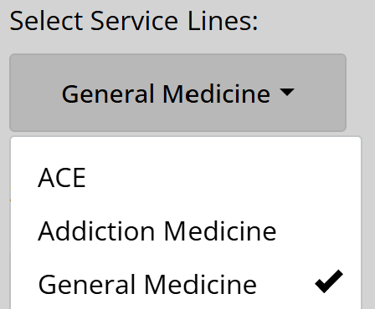
  - Show or hide the dotted capacity lines

  - Plot combinations of groups together by using the slider
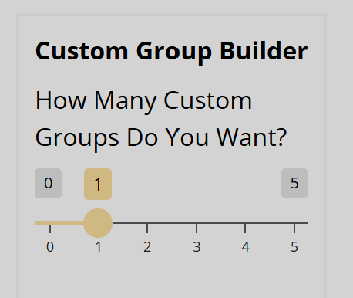
  - And choosing groups to add together in a single line in the resulting drop down boxes, and providing a specific group name if desired.
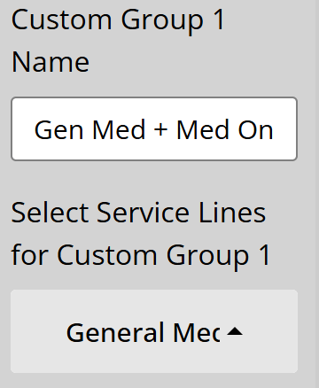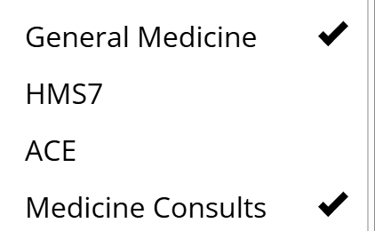
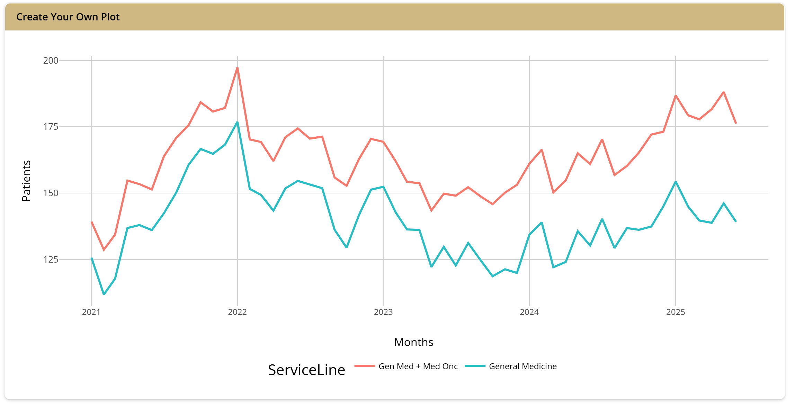
- Note that individual cards for the selected Service Lines will populate beneath the main plot when selected.
